

**BDT WEEK 7**

**NAME:**  **DATE:** 13 /11/2024

**ROLL NUMBER:** **BRANCH:** CSD-B

**PROBLEM STATEMENT :**

1)Practice Basic HiveQL commands,read data from various File Formats and create data definition statements and data manipulation statements

2)Write queries using select.

**CODE:**

**1)Opening hive:** open the terminal and type ‘hive’

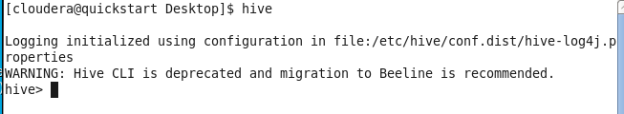

**2)creating and using database:**

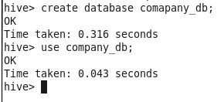

**3)creating the tables:**

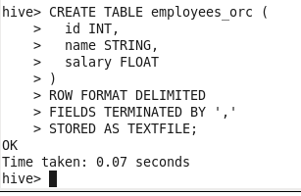

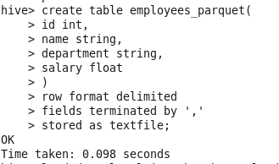

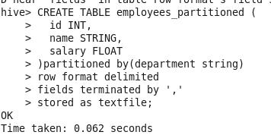

**4)load the data:**

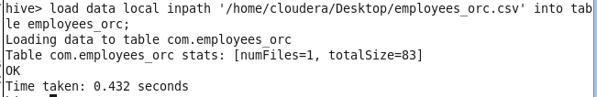

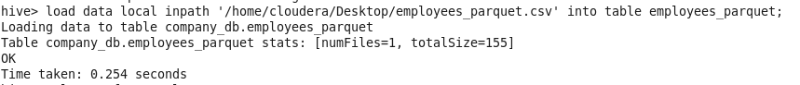

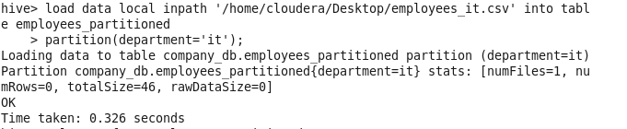

**5)Inserting the data manually:**

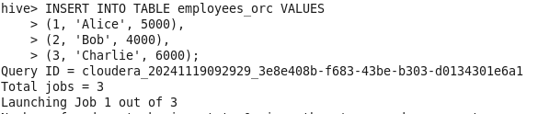

**6)Performing queries:**

**Basic query:**

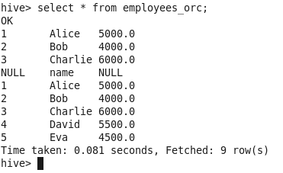

**Filter employees by salary:**

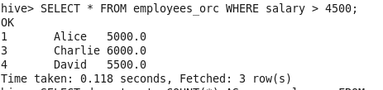

**Aggregate queries:**

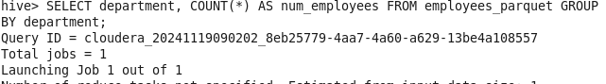

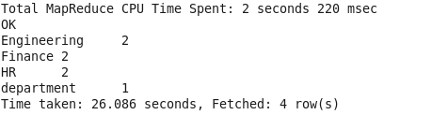

**Finding Average salary by department and filter results using HAVING :**

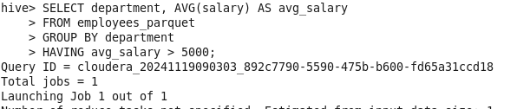

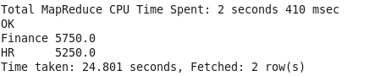

**Join query:**

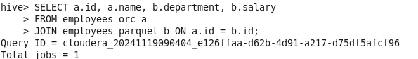

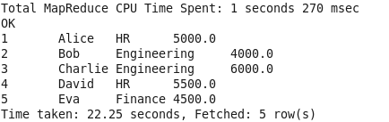

**Partition operations:**



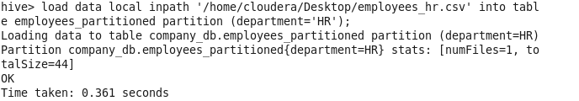

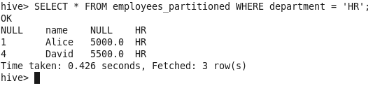

**Creating and using VIEWS:**

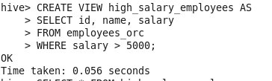

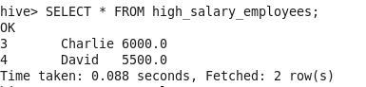

**Rename the column salary to annual_salary:**

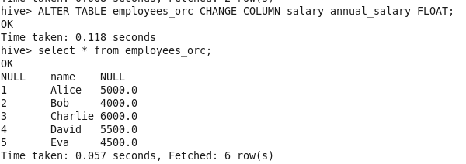

**Showing tables and databases:**

